

Handwriting at Arnesby School

Handwriting
At Arnesby Church of England Primary School we are very proud of our pupil’s handwriting and take particular care in our cursive handwriting style. We use Letter-join’s on-line handwriting resources as the basis of our handwriting policy.
Objective
Handwriting is a basic skill that influences the quality of work throughout the curriculum. By the end of Key Stage 2 all pupils should have the ability to produce fluent, legible and, eventually, speedy joined-up handwriting, and to understand the different forms of handwriting used for different purposes.
Our intention is to make handwriting an automatic process that does not interfere with creative and mental thinking.
Aims:
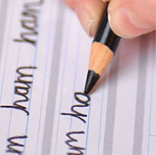
- To develop a neat, legible, speedy handwriting style using continuous cursive letters, which leads to producing letters and words automatically in independent writing.
- To establish and maintain high expectations for the presentation of written work.
- For pupils to understand, by the end of Year 6, the importance of neat presentation and the need for different letterforms (cursive, printed or capital letters) to help communicate meaning clearly.
Expectations
All teaching staff are encouraged to model the cursive style in all their handwriting, whether on whiteboards, displays or in pupils’ books to ensure consistency throughout the school. Pupils are encouraged to take pride in the presentation of their work. Our objective is to help pupils enjoy learning and developing their handwriting with a sense of achievement and pride.
Handwriting frequency
Handwriting is a cross-curricular task and will be taken into consideration during all lessons. Formal teaching of handwriting will be carried out regularly and systematically to ensure Key Stage targets are met.

Pens and pencils
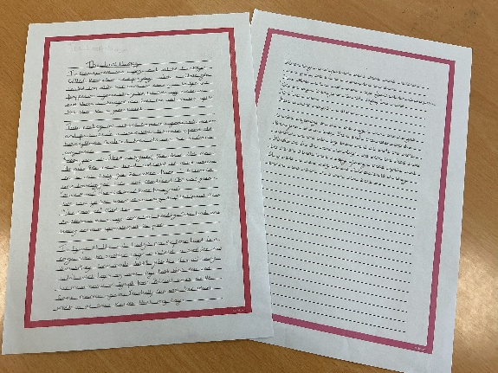
Children will start handwriting using a soft pencil. When fine motor skills have been established and children are writing consistently, neatly and fluently, a handwriting pen licence will be given, and children may then write in pen or pencil. It is expected that by year 5 children will be using pens.

Inclusion
For children who experience handwriting difficulties due to fine motor development, including those who are left-handed and those with special educational needs, the appropriate additional support will be put into place.
Handwriting at Home
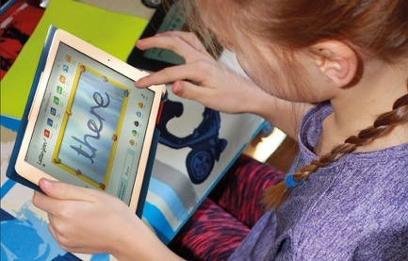
Pupils are encouraged to practise their handwriting at home by using the Pupil log-in for Letter-join. Teachers can set specific tasks such as:
- Magic Patterns
- Magic Words
- Phonics Match
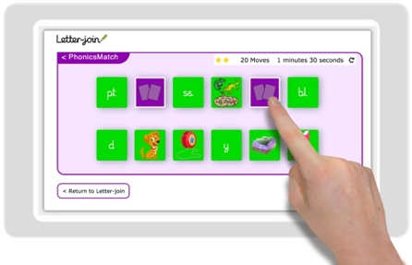
- Word Search
- Word Bank
- Write it Right!
Children can also watch the word and letter animations and practice and explore other handwriting resources on Letter-join.

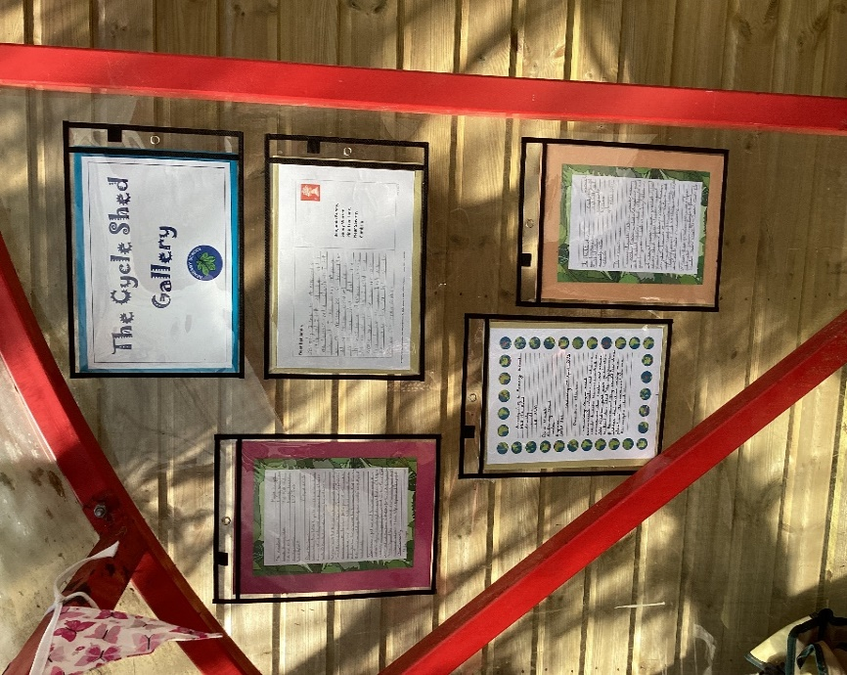
The cycle shed gallery often show writing examples of learning from across the school.

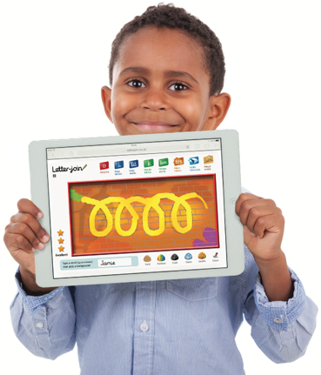
Early Years
For our youngest pupils we teach short handwriting lessons on a daily basis, which will include the following:
- enhancing gross motor skills such as air-writing, pattern-making and physical activities
- exercises to develop fine motor skills such as mark-making on paper, whiteboards, sensory trays, iPads, tablets, etc.
- becoming familiar with letter shapes, their sounds, formation and vocabulary
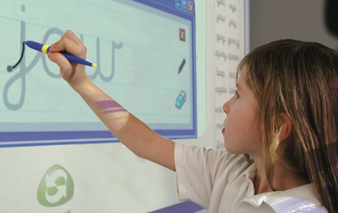
- correct sitting position and pencil grip for handwriting
Printed letters is teaching handwriting with printed letters.
Supporting resources using a printed font include:
- all lower case letters and words
- all of the phonics activities
- all games and activities
- all KS1 worksheets

EYFS teaches pre-cursive patterns and cursive, lower case letters. It starts with Getting Ready for Handwriting including fine and gross motor skills warm-up exercises, correct sitting position and tripod pencil grip.
Key Stage 1: Years 1 and 2
Teaching progresses and includes:
- continuing with gross and fine motor skills exercises
- strengthening cursive handwriting, learning and practice
- numerals, capitals and printed letters; where and when to use, learning and practice
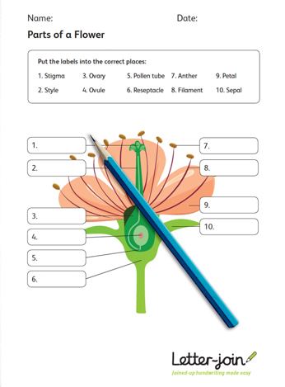
Year 1 teaches how to write capital letters, numbers and symbols, whilst reinforcing cursive handwriting using Letter-join’s on-line and printed resources.
Children should be confident in writing all the capital and printed letters, numbers and symbols and start to become familiar with their use.

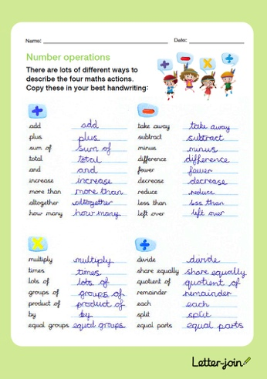
Year 2 includes improving letter formation and orientation of letters through regular practice and to support spelling, grammar and punctuation. The covers:
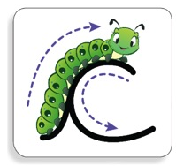
- letter families
- high frequency words
- joining techniques
- sequencing sentences
- dictation exercises
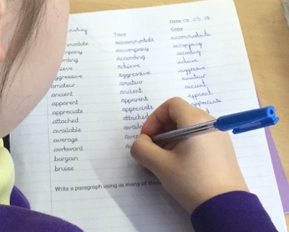
- SPaG practice
With the regular handwriting practice children should now be developing the fluency and speed of their writing.

Key Stage 2: Years 3 and 4
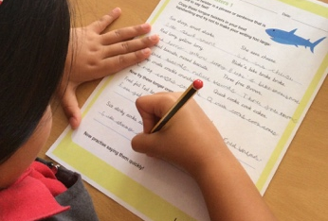
Year 3 and Year 4 is targeted at children in lower KS2 where pupils should be using a cursive style throughout their independent writing in all subjects, helping to refine their handwriting in line with the requirements of each lesson. Topics such as dictation, double letters, number vocabulary, tongue twisters and statutory spellings.
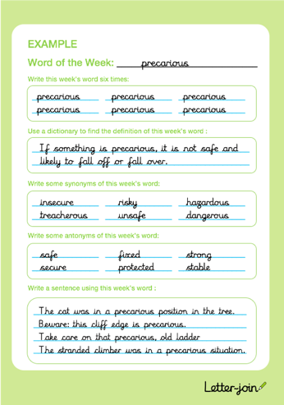
Children should see improvement in the legibility, consistency . Handwriting practice supports other subjects in the curriculum and, at the same time, builds on fluency and consistency. Children will continue to build on producing fluent, consistent and legible handwriting through the regular practice and they will have practised applying size-appropriate handwriting to all areas of the curriculum whilst maintaining fluency and legibility.
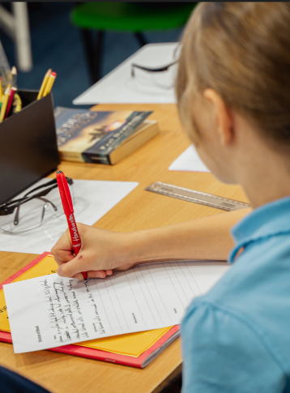
Key Stage 2: Years 5 and 6
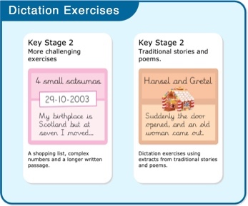
More advanced handwriting techniques are taught in these years continues to build on combining fluent handwriting with other subjects across the curriculum.
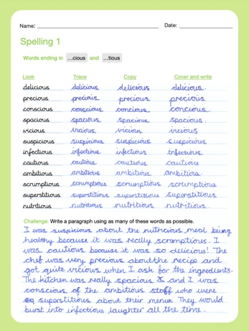
- reinforcing cursive handwriting across the curriculum
- dictation exercises promoting quick note- taking and speedy handwriting writing skills
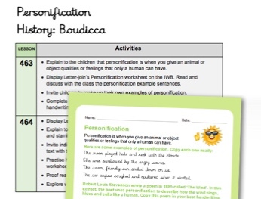
- KS2 SATs SPaG practice
Children have the opportunity to develop stamina and skills to write at length, with accurate spelling and punctuation to work towards producing consistently neat and well-presented handwriting in all curriculum subjects.
CORRECT POSTURE AND PENCIL GRIP FOR HANDWRITING
Pupils should be taught to sit correctly at a table, holding a pencil comfortably and correctly.
Sitting position
Sit with a straight back, not leaning over the page
Pull the chair close in to the table
Keep feet flat on the floor
Sit right back in the seat
The table reaches to below elbow height

Paper position for right-handed children.

Left-handed children
Left-handed children may find it difficult to follow the movements of right-handed teachers as they model letter formation (and vice versa). Teachers demonstrate to left-handers on an individual or group basis.
- Left-handed pupils should sit to the left of a right-handed child so that they are not competing for space.
- Pupils should position the paper/book to their left side and slanted, as shown.
- Pencils should not be held too close to the point as this can interrupt pupils’ line of
vision.
- Extra practice with left-to-right exercises may be necessary before pupils write
left-to-right automatically.
Paper position for left-handed children.

THE TRIPOD PENCIL GRIP
Both right and left handed children should be encouraged to use the tripod grip which allows the pen/pencil to be held securely whilst allowing controlled movements of the pen/pencil nib. We use the Tripod Grip Rhyme:
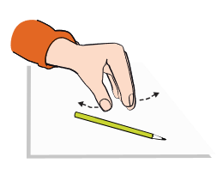
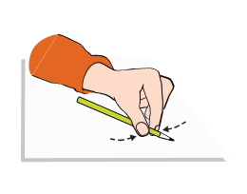
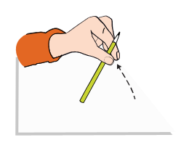
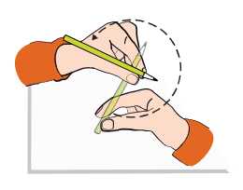
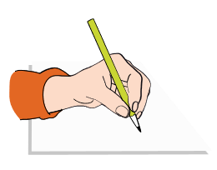
Point away the pencil, Pinch it near the tip, Lift if off the table, Spin it round... and grip.
Point away the pencil, Pinch it near the tip, Lift if off the table, Spin it round... and grip.
RIGHT-HANDED PENCIL GRIP
LEFT-HANDED PENCIL GRIP

